MODULE 6
— Nested loops: online judge problems
QUES 1. CODE:
#include <stdio.h>

int main() {
int n;
scanf("%d", &n);

for (int i = 1; i <= n; i++) {

// Print spaces
for (int j = 1; j <= n - i; j++) {
printf(" ");
}

// Print #
for (int j = 1; j <= i; j++) {
printf("#");
}

printf("\n");
}

return 0;
}

SCREENSHOT:
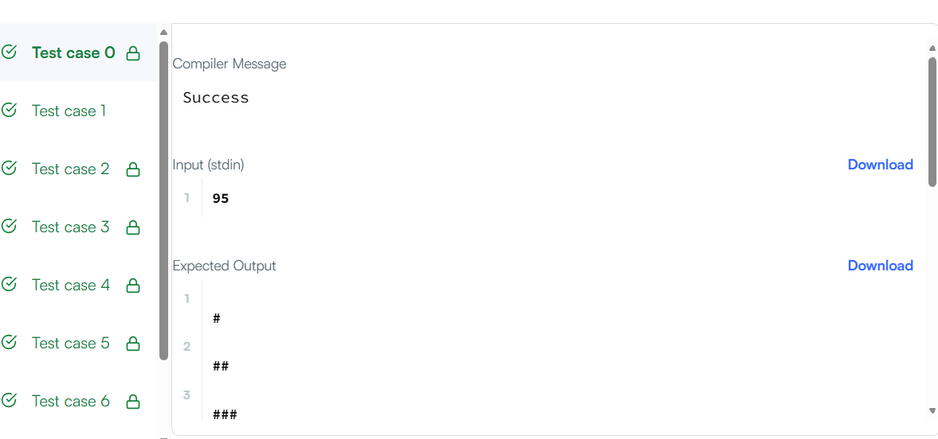
URL: https://www.hackerrank.com/challenges/staircase/problem
QUES 2. CODE:
#include <stdio.h>

int main() {
int n;
scanf("%d", &n);

int size = 2 * n - 1;

for (int i = 0; i < size; i++) {
for (int j = 0; j < size; j++) {

int top = i;
int left = j;
int bottom = size - 1 - i;
int right = size - 1 - j;

int min = top;

if (left < min)
min = left;

if (bottom < min)
min = bottom;

if (right < min)
min = right;

printf("%d ", n - min);
}

printf("\n");
}

return 0;
}
SCREENSHOT:
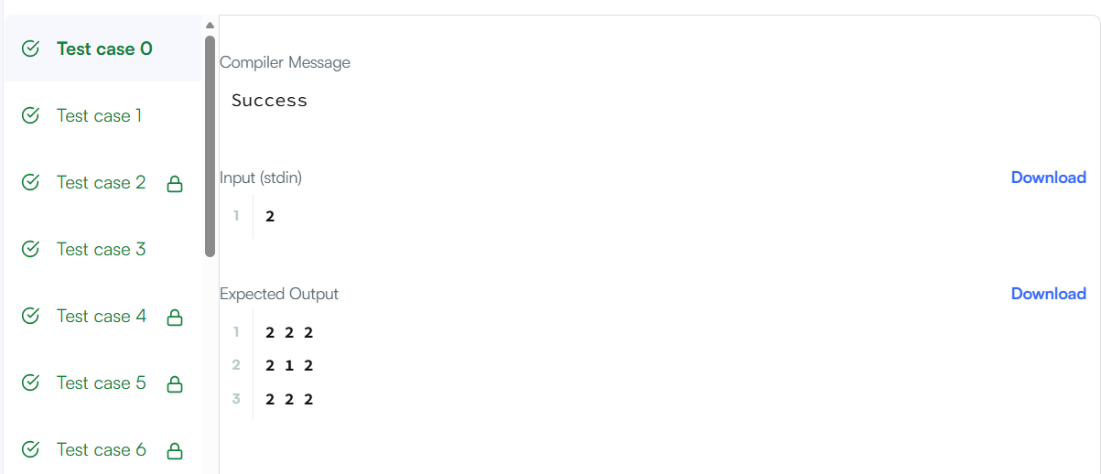
URL: https://www.hackerrank.com/challenges/printing-pattern-2/problem

